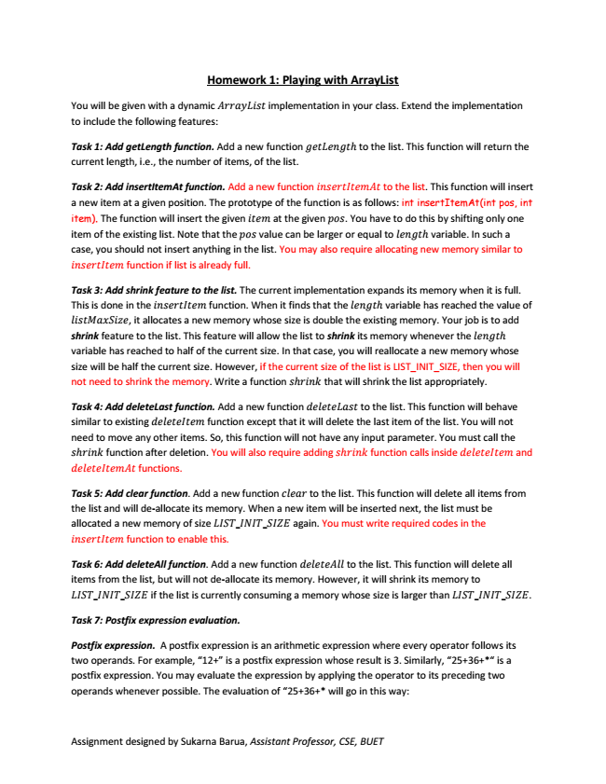

**Homework 1: Playing with ArrayList**

You will be given with a dynamic implementation in your class. Extend the implementation to include the following features:

Task 1: Add getLength function. Add a new function h to the list. This function will return the current length, i.e., the number of items, of the list.

Task 2: Add insertItemAt function. Add a new function to the list. This function will insert a new item at a given position. The prototype of the function is as follows: int insertItemAt(int pos, int item). The function will insert the given at the given . You have to do this by shifting only one item of the existing list. Note that the value can be larger or equal to h variable. In such a case, you should not insert anything in the list. You may also require allocating new memory similar to

function if list is already full.

Task 3: Add shrink feature to the list. The current implementation expands its memory when it is full. This is done in the function. When it finds that the h variable has reached the value of

, it allocates a new memory whose size is double the existing memory. Your job is to add shrink feature to the list. This feature will allow the list to shrink its memory whenever the h variable has reached to half of the current size. In that case, you will reallocate a new memory whose size will be half the current size. However, if the current size of the list is LIST_INIT_SIZE, then you will not need to shrink the memory. Write a function h that will shrink the list appropriately.

Task 4: Add deleteLast function. Add a new function to the list. This function will behave similar to existing function except that it will delete the last item of the list. You will not need to move any other items. So, this function will not have any input parameter. You must call the

h function after deletion. You will also require adding h function calls inside and

functions.

Task 5: Add clear function. Add a new function to the list. This function will delete all items from the list and will de-allocate its memory. When a new item will be inserted next, the list must be allocated a new memory of size _ _ again. You must write required codes in the

function to enable this.

Task 6: Add deleteAll function. Add a new function to the list. This function will delete all items from the list, but will not de-allocate its memory. However, it will shrink its memory to

_ _ if the list is currently consuming a memory whose size is larger than _ _ .

***Task 7: Postfix expression evaluation.***

Postfix expression. A postfix expression is an arithmetic expression where every operator follows its two operands. For example, “12+” is a postfix expression whose result is 3. Similarly, “25+36+*“ is a postfix expression. You may evaluate the expression by applying the operator to its preceding two operands whenever possible. The evaluation of “25+36+* will go in this way:

Assignment designed by Sukarna Barua, Assistant Professor, CSE, BUET

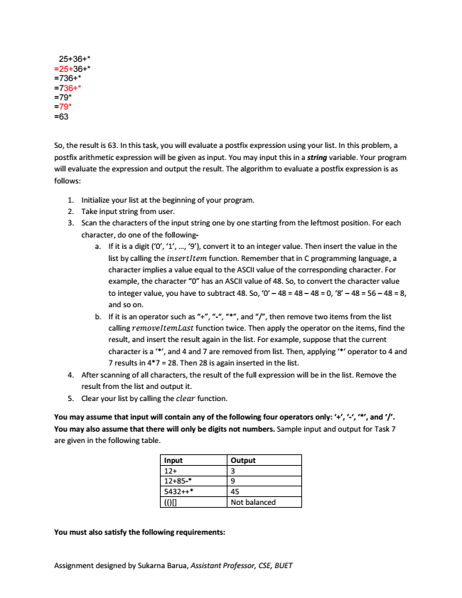

25+36+* =25+36+* =736+* =736+* =79* =79* =63

So, the result is 63. In this task, you will evaluate a postfix expression using your list. In this problem, a postfix arithmetic expression will be given as input. You may input this in a string variable. Your program will evaluate the expression and output the result. The algorithm to evaluate a postfix expression is as follows:

1. Initialize your list at the beginning of your program. 2. Take input string from user. 3. Scan the characters of the input string one by one starting from the leftmost position. For each

character, do one of the following-

a. If it is a digit (‘0’, ‘1’, ..., ‘9’), convert it to an integer value. Then insert the value in the list by calling the function. Remember that in C programming language, a character implies a value equal to the ASCII value of the corresponding character. For example, the character “0” has an ASCII value of 48. So, to convert the character value to integer value, you have to subtract 48. So, ‘0’ – 48 = 48 – 48 = 0, ‘8’ – 48 = 56 – 48 = 8, and so on. b. If it is an operator such as “+”, “-“, “*”, and “/”, then remove two items from the list

calling function twice. Then apply the operator on the items, find the result, and insert the result again in the list. For example, suppose that the current character is a ‘*’, and 4 and 7 are removed from list. Then, applying ‘*’ operator to 4 and 7 results in 4*7 = 28. Then 28 is again inserted in the list. 4. After scanning of all characters, the result of the full expression will be in the list. Remove the

result from the list and output it. 5. Clear your list by calling the function.

**You may assume that input will contain any of the following four operators only: ‘+’, ‘-‘, ‘*’, and ‘/’. You may also assume that there will only be digits not numbers. Sample input and output for Task 7 are given in the following table.**

Input Output 12+ 3 12+85-* 9 5432++* 45 (()[] Not balanced

**You must also satisfy the following requirements:**

Assignment designed by Sukarna Barua, Assistant Professor, CSE, BUET

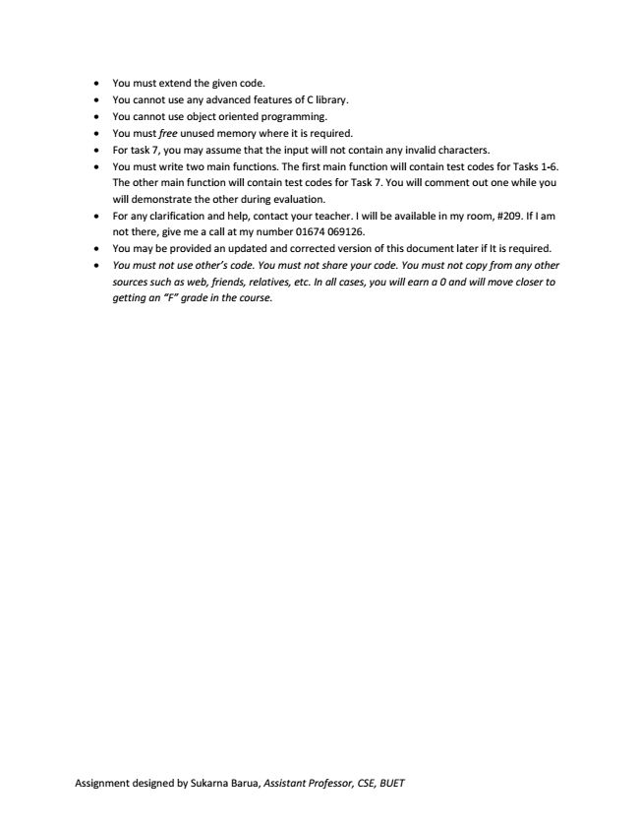

• You must extend the given code.

• You cannot use any advanced features of C library.

• You cannot use object oriented programming.

• You must free unused memory where it is required.

• For task 7, you may assume that the input will not contain any invalid characters.

• You must write two main functions. The first main function will contain test codes for Tasks 1-6. The other main function will contain test codes for Task 7. You will comment out one while you will demonstrate the other during evaluation.

• For any clarification and help, contact your teacher. I will be available in my room, #209. If I am not there, give me a call at my number 01674 069126.

• You may be provided an updated and corrected version of this document later if It is required.

*• You must not use other’s code. You must not share your code. You must not copy from any other sources such as web, friends, relatives, etc. In all cases, you will earn a 0 and will move closer to getting an “F” grade in the course.*

Assignment designed by Sukarna Barua, Assistant Professor, CSE, BUET